**Overall Score: 41/50**

1. Q2: Which of the following has the greatest potential for compromising a user’s personal privacy?

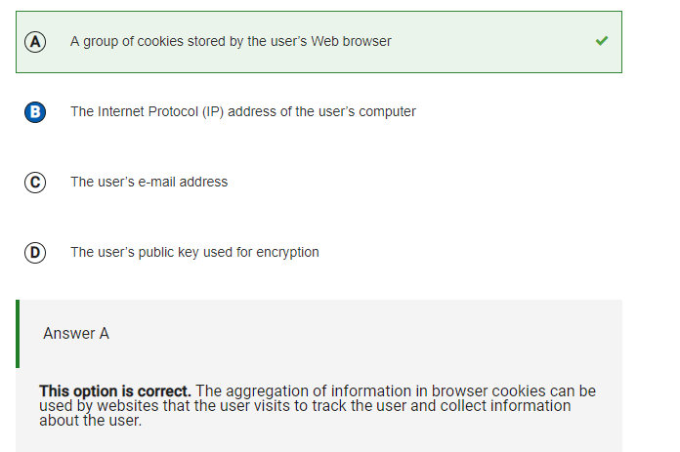

* I originally chose IP address, but I learned that the IP address doesn’t contain any extra information about the user, while cookies can
* Cookies can be used to track the user and collect information about the user

1. Q8: Which of the following are true statements about digital certificates in Web browsers?

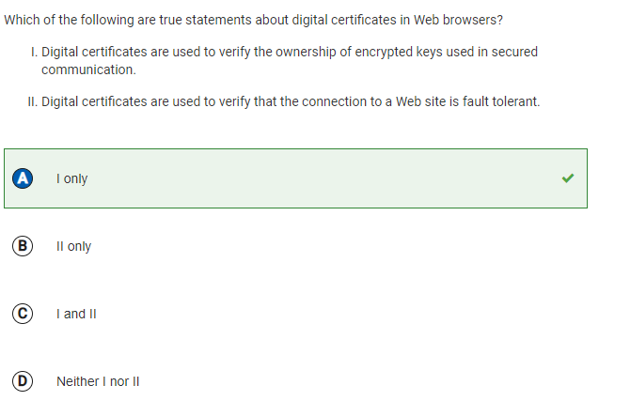

* I didn’t know what digital certificates were, at first
* I learned that digital certificates help verify who the sender of communications are
* It verifies the identity of a website/server and establishes an encrypted connection between the server and the person’s browser
* Used to ensure authenticity of online transactions, ie. online banking, emails, etc.
* Client’s web browser connects to website with digi certificate --> browser verifies authenticity by checking digital signature and identity of certificate authority --> certificate is valid --> website’s identity is confirmed --> browser establishes secure, encrypted connection
* Helps protect privacy of data being transmitted between user and server

1. Q22

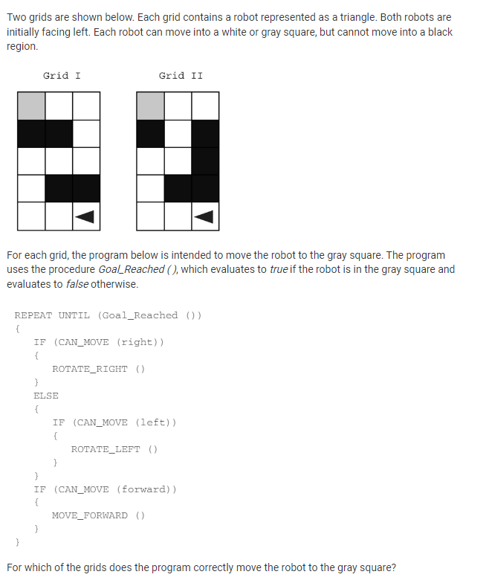

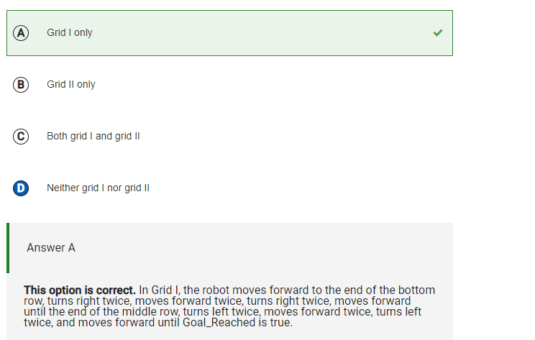

* I oriignally selected D, because I thought that the robot would just run into the wall

1. Q23

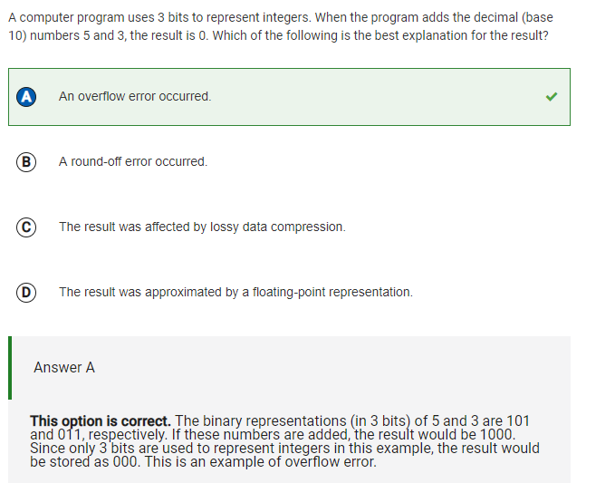

* I learned that an overflow error is when a program gives a result that’s outside the range of values that can be represented by the used data type/variable
* 5 + 3 gets a value of 8
* Max value 3 bits can store is 7
* 8 > 7 ---> OVERflow error

1. Q24

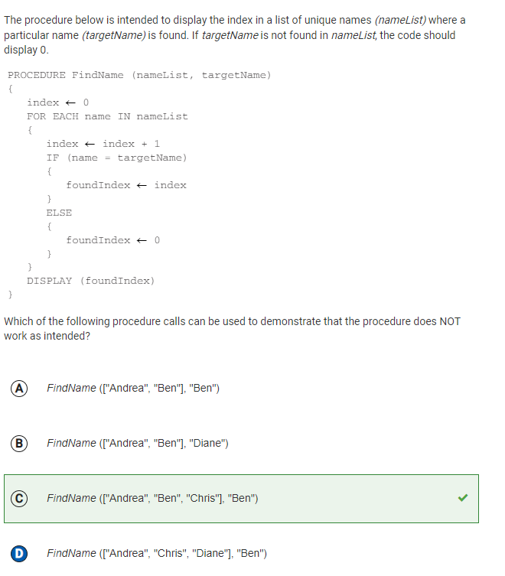

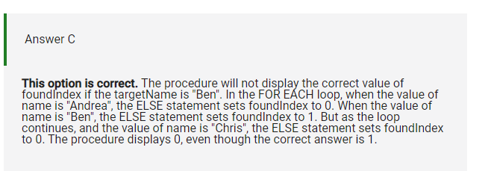

* I thought that option D would show that the procedure was wrong, however, it would work because it would display 0 since “ben” isn’t in the list
* C is correct. Because the foundIndex gets changed back to 1 when it continues the loop to “chris”

1. Q25

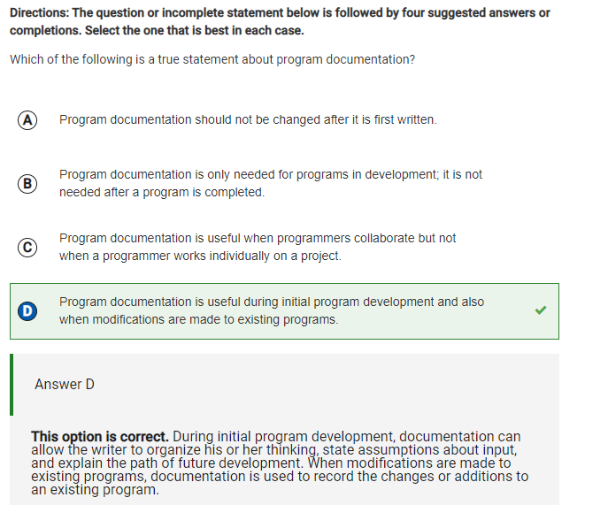

* I learned that program documentation is used to describe the design, functionality, and purpose of a program
* It helps developers and users understand howthe program works
* Can include: system design documents, user manuals, installation guides, API reference guides, code comments, technical specifications, and release notes
* Should be written through the development process, and as modifications are made; through testing, deployment, and maintenance too -- can save time and effort, reduce errors, and improve usability of software

1. Q28

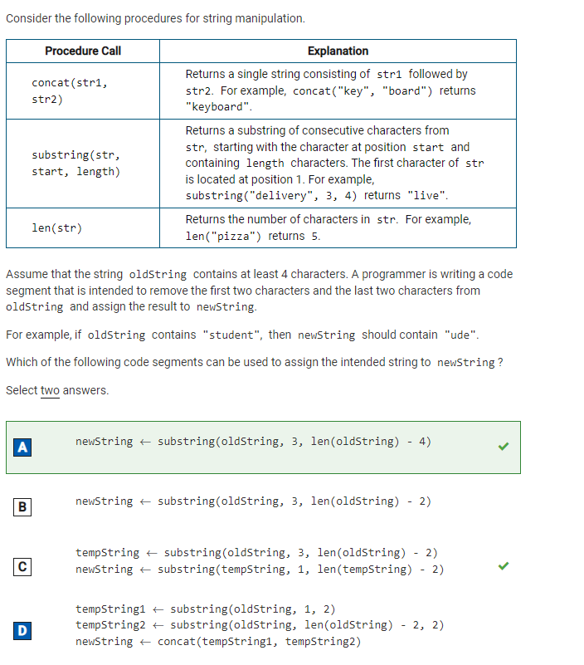

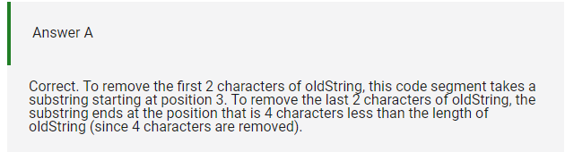

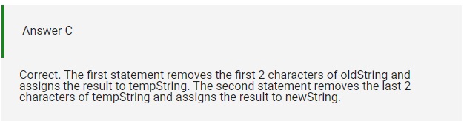

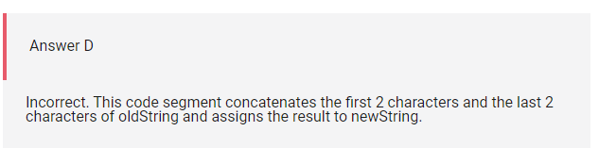

1. Q29

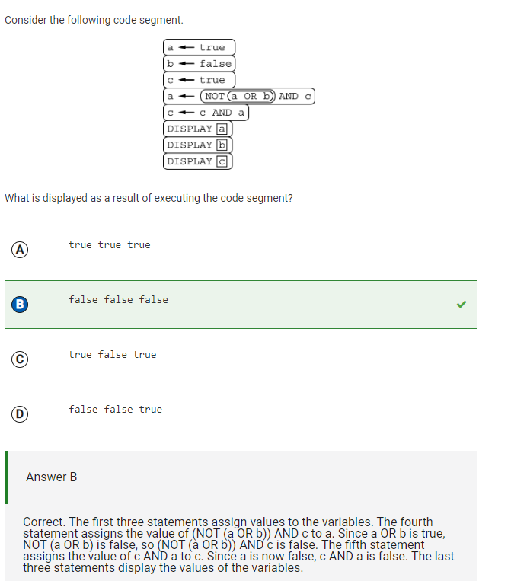

1. Q33

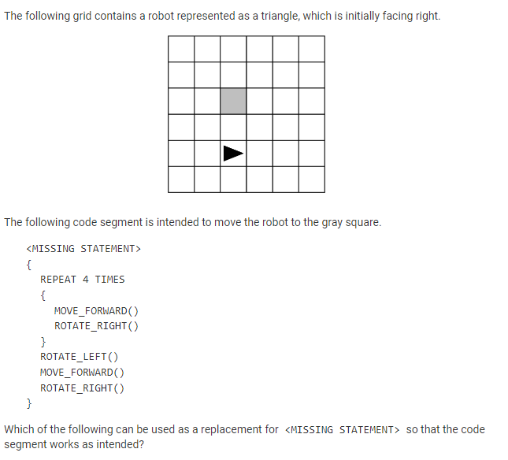

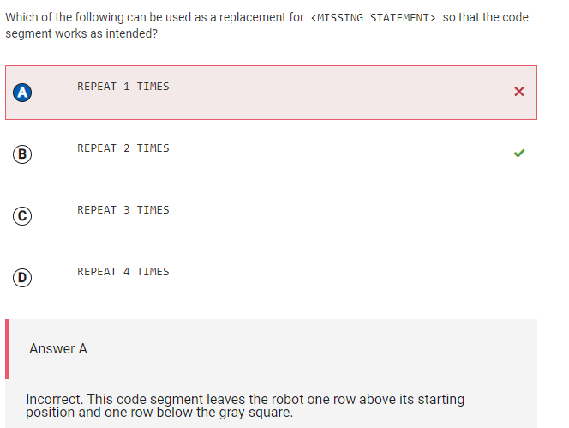

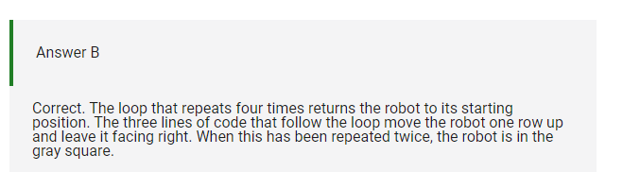

1. Q34

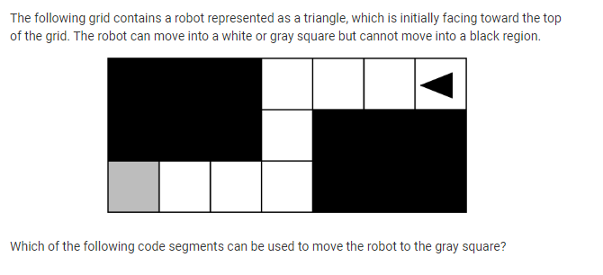

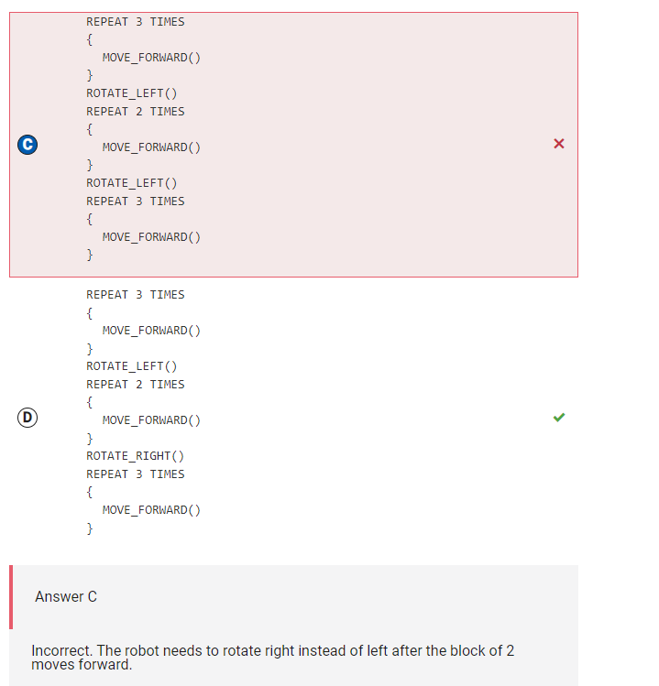

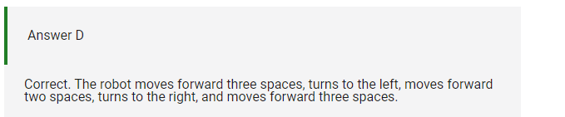

* Was a silly mistake on my part

1. Q39

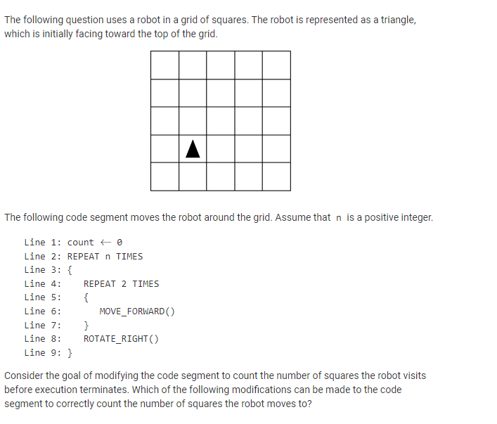

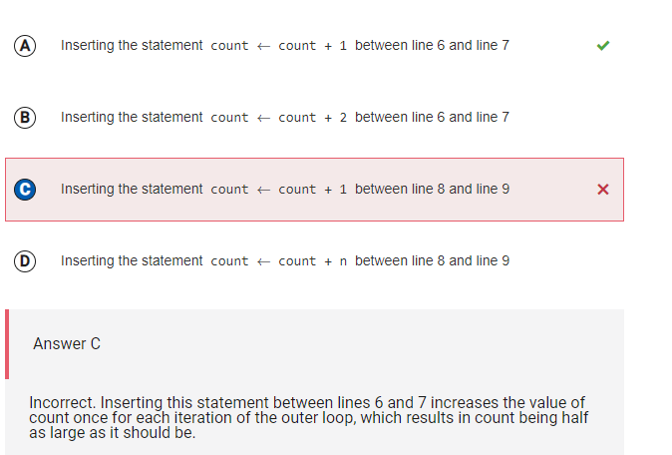

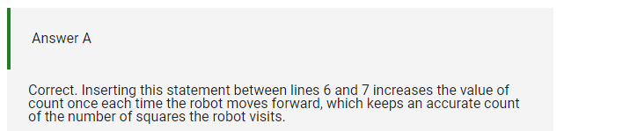

* The robot moves forward at line 6, so it would only make sense for it to count how many squares were hit after each time it moved forward
* So of course the count should be increased between line 6 and 7

1. Q40

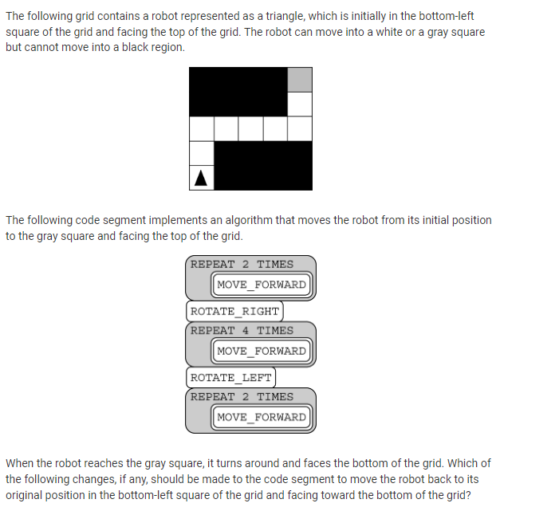

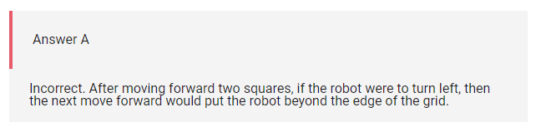

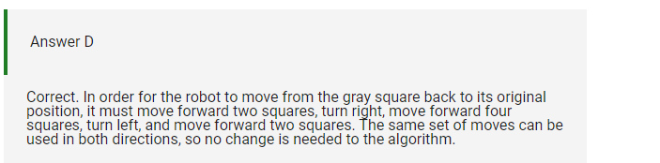

1. Q41

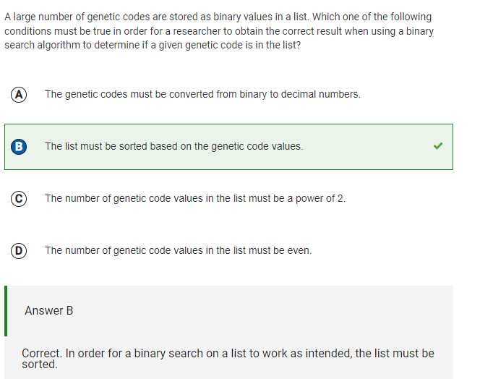

* I learned that in order for a binary search to be performed, the list needs to be sorted in either an ascending or descending order

1. Q45

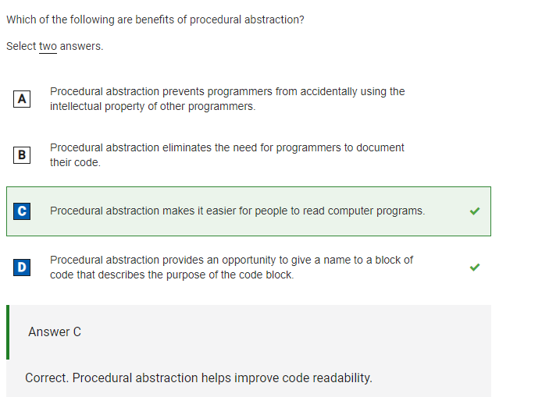

* I learned that procedural abstraction is breaking down a larger and more complex system into smaller, manageable parts
* Has many benefits, such as being able to re-use procedures at multiple points in the same program or even in different programs, thus making the code easier to manage and making it easier to update programs
* Allows programmers to create modular code that is easier to understand, test, and debug
* Breaks down complex tasks into smaller procedures
* Programmers can focus ion individual parts of the program at a time
* Improves overall quality of code
* Reusability & Modularity

1. Q50

